RENÈ PROFESSIONAL – PURERENÈ CARE

I know, I am often in love. At least, I often say I'm in love. Or that I found a new love. But this time I get real butterflies in my stomach. And not only me, Nevzat has the butterflies too. When it will all go well with the salon we even want to see if we can bring the products here on the market. Anyway we would like to work with the products in any case. But enough about that, I would like to introduce our new love to you. René has been a hairdresser for over twenty years and has founded René Professional in 2007. René Professional has brought two lines into the market; ARTcolor and PureRené. Today I would love to tell you something about the products of PureRené.

[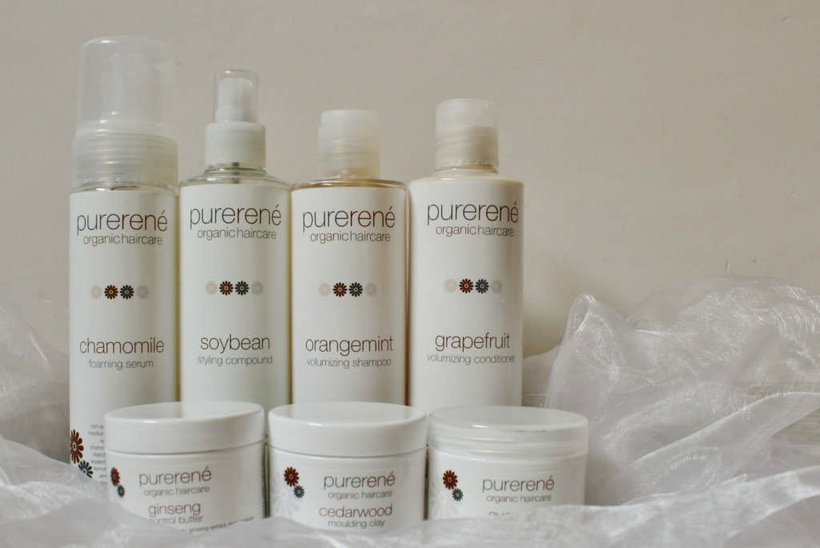](http://bohalista.com/wp-content/uploads/2014/11/Purerene.jpg)

René Professional products are characterized by the balance between human and nature. The products contain quality ingredients, mainly plant extracts and essential oils. On top of this the ingredients are organic and Fairtrade. Also during the creation of the packaging nature has been thought of. The bottles are refillable and so the environment is spared. I told you; a man of my heart! At the moment I am using the shampoo, conditioner, conditioner spray, mousse and clay. In the salon we have (as a trial) the whole line in use and we are so pleased with these that we really hope that we can work with the products after the trial period.

**Orangemint Shampoo**

[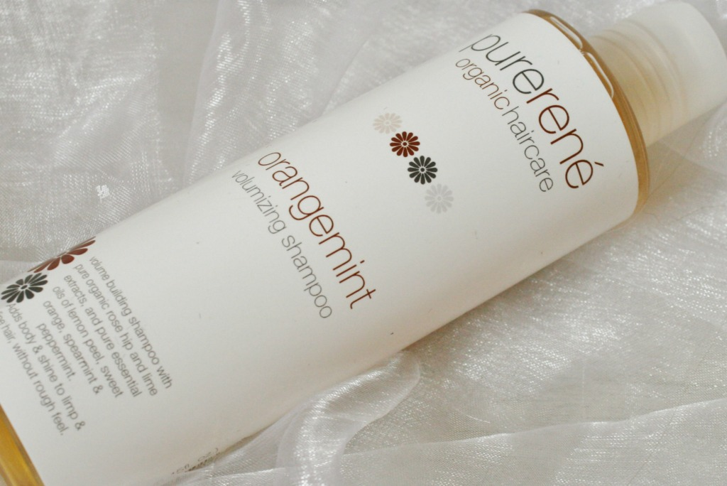](http://bohalista.com/wp-content/uploads/2014/11/purerene-orangemint-shampoo.jpg)

Orangemint is a shampoo with volume organic soy proteine, brier, lime-extract, pure essential oils of peppermint and citrus fruit and is enriched with vitamin E. The shampoo promises to give body and shine to lifeless hair. The shampoo is also available in Patchouli as nutritient, softening and detangling shampoo for dry and damaged hair and Sassafras, as a daily shampoo. The bottle contains 250 ml and the costs are around twenty euros.

[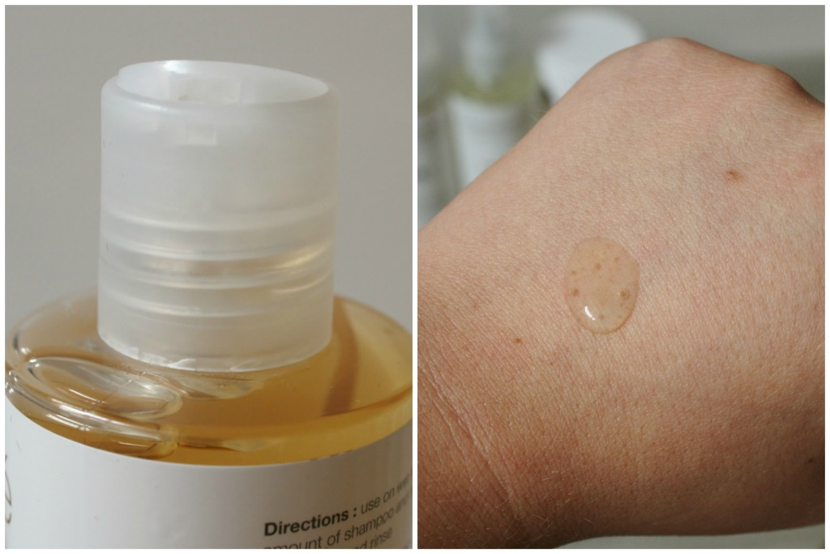](http://bohalista.com/wp-content/uploads/2014/11/Orangemint-shampoo-PureRene.jpg)

The PureRenè Orangemint shampoo is in a handy bottle that exactly shows youhow much shampoo is left in the bottle. The structure of the shampoo is a little *gelly*-ish. You don’t need much shampoo to wash the whole hair and the shampoo is very easy to divide. The shampoo foams hardly, but cleanses the hair thoroughly. I’m a big fan of the scent; a fresh scent with a slight haze of citrus. After using the shampoo, my hair feels pretty dull and inflexible. Therefore I use it -as indicated on the bottle- in combination with the conditioner. After washing my hair it clearly has more volume.

**Grapefruit Volumizing Conditioner**

[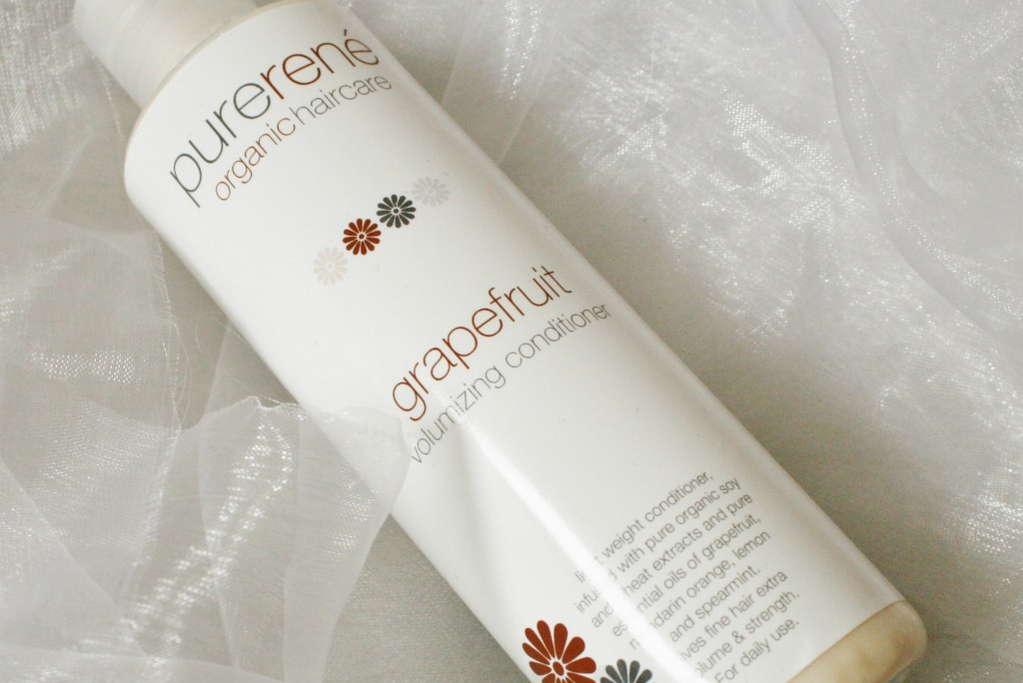](http://bohalista.com/wp-content/uploads/2014/11/purerene-grapefruit-volumizing-conditioner.jpg)

[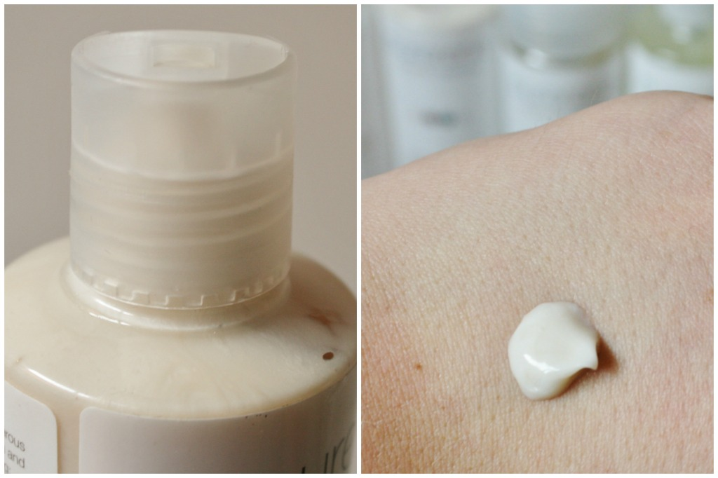](http://bohalista.com/wp-content/uploads/2014/11/Purerene-conditioner.jpg)Grapefruit Volumizing Conditioner is a conditioner with organic soya- and wheat extracts and pure essential oils of citrus fruits and green mint. The conditioner promises to give extra volume, strength and protection against UV radiation for fine and lifeless hair. The conditioner is enriched with vitamin E and suitable for everyday use. Also available are the conditioning cream Jojoba to hydrate the hair, intensive Spirulina balm to protect hair from styling and blow drying and leave-in conditioner Ylang Ylang for dry and damaged hair. A bottle contains 250 ml and costs about twenty euros.

T

The PureRenè Grapefruit Volumizing Conditioner is in the same kind as the shampoo bottle. The bottle is easy to hold and is well locked. By means of the shell it can be dosed well, I personally like the conditioner so much that I often use much more than necessary. Much to the annoyance of Nevzat. The conditioner is thick, deliciously creamy and easy to divide. I use the conditioner in combination with the shampoo, then my hair feels pretty stiff, but once the conditioner touches my hair-and I'm not exaggerating- I feel my hair soften. You must let the conditioner detangle your hair well and meanwhile continue combing your fingers through your hair. Let the product set 1 to 3 minutes. Every time I washed my hair with this shampoo and conditioner my tangles disappeared. My hair feels soft and healthy, and you clearly see visible volume. After I use my hair dryer, I have to do little to bring my hair into model

**Ylang Ylang Conditioning Mist**

[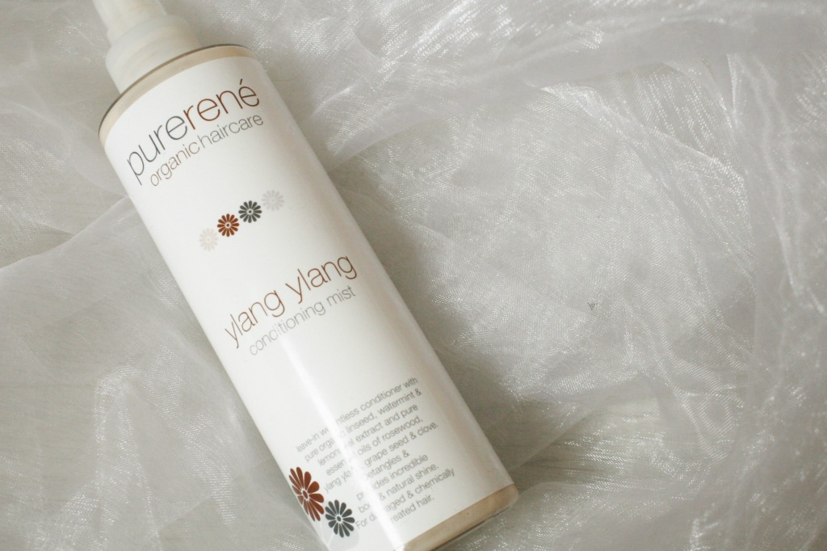](http://bohalista.com/wp-content/uploads/2014/11/Ylang-Ylang-Conditioning-Mist.jpg)

Ylang Ylang Conditioning Mist is a leave-in conditioner for dry and damaged hair with organic flaxseed, watermint, lemon extracts and pure essential oils of rosewood, ylang ylang, grape seed and cloves.

The conditioning mist detangles hair and provides volume and a beautiful natural shine.

[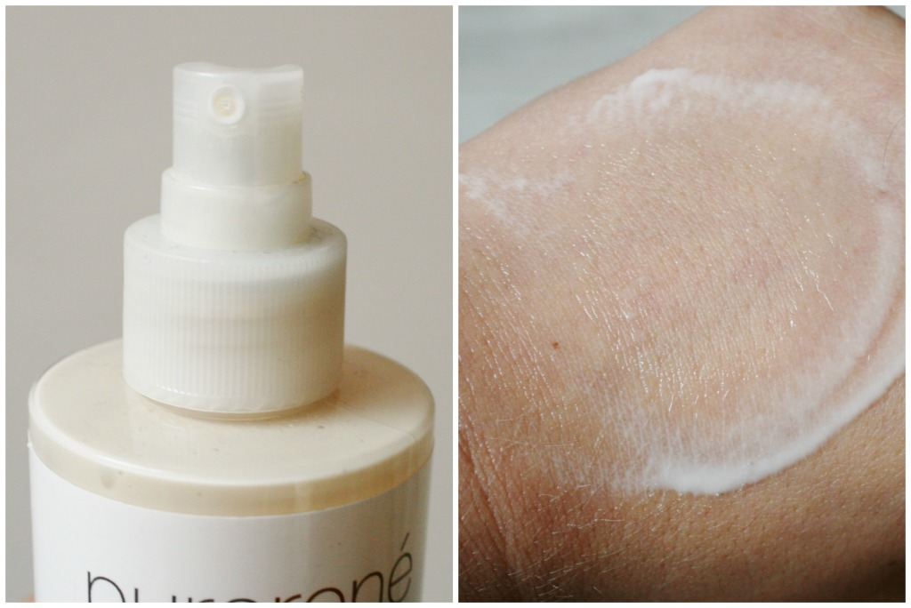](http://bohalista.com/wp-content/uploads/2014/11/Ylang-Ylang-Conditioning-Mist-Purerene.jpg)

[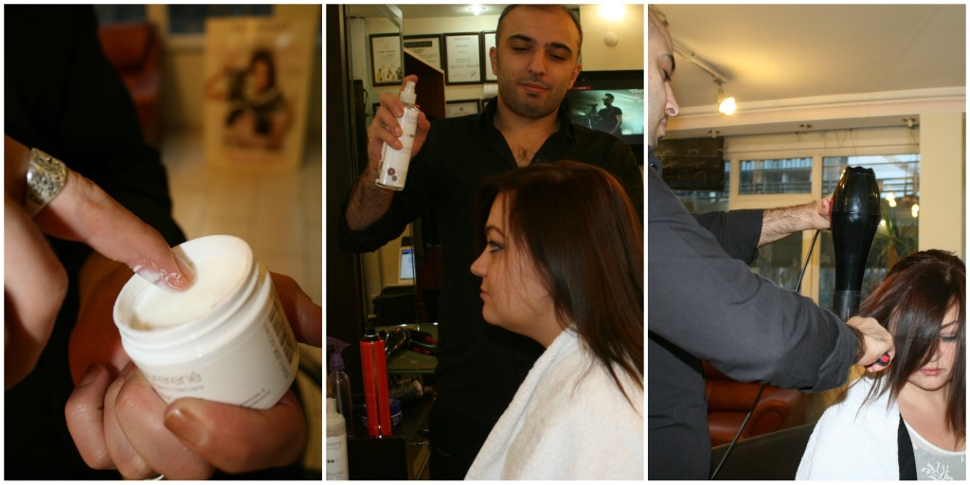](http://bohalista.com/wp-content/uploads/2014/12/Rene-Salon.jpg)The PureRenè Ylang Ylang Conditioning Mist is in a similar kind of bottle like shampoo and conditioner, but includes a nozzle. The bottle is easy to hold, so you can spray the mist through your hair. The spray has a water-like structure and has a subtle blossom fragrance that I personally find very lovely. If desired, you can untangle by running your hands through your hair after applying the spray to towel dried hair. I use it myself often to detangle my hair. My hair tangles very quickly and really gets impossible tangles often. If they are really hard to go out and I don’t want to ask Nevzat for help, I just spray a little Ylang Ylang Conditioning Mist in my hair. After that it is much easier to comb out. I think this is my favorite product from the line PureRenè.

All products by Renè Professional are free from SLS, parabens and silicones and obtainable in the better hairdresser salon’s. The prices are on average around twenty for a product. It seems redundant to say again that I think the products are really very good, because that seems obvious now. We used the products for a while now in the salon with a certain group of customers and they are all very excited.

[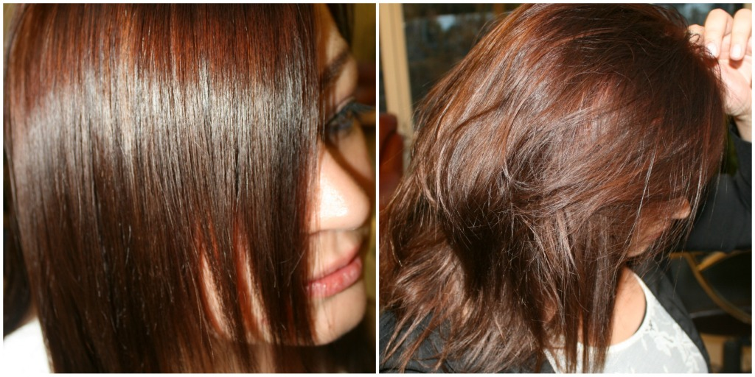](http://bohalista.com/wp-content/uploads/2014/12/Rene-Professional-Salon.jpg)